**JULY**

July 11 Thurs Membership Meeting (Rosary 6:30/Meeting 7:00)

July 13 Sat State Officer Meeting in Fairfax (8:30am)

July 25 Thurs Officer Meeting 7:00 pm

July 27 Sat Officer Installation (Ceremony and Reception) 7:00 pm

**August**

Aug 1 Thurs Membership Meeting (Rosary 6:30/Meeting 7:00)

Aug 17-18 Sat –Sunday BBQ to Go (after all Masses)

Aug 29 Thurs Officer Meeting 7:00 pm

**September**

Sept 5 Thurs Membership Meeting (Rosary 6:30/Meeting 7:00)

Sept 18 Wed Exemplification at Holy Family 7:00pm

Sept 21 Sat Food Drive for Holy Family (10:00am-12:00 noon)

Sept 26 Thurs Officer Meeting 7:00 pm

**Octobe**r

Oct 3 Thurs Membership Meeting (Rosary 6:30/Meeting 7:00)

Oct 5 Sat Soccer Challenge at Salem High School (9:00am)

Oct 5 Sat Oktoberfest after 5:30 Mass

Oct 19 Sat State Officer Quarterly Meeting (Newport News) (8:30am)

Oct 26 Sat District Deputy Meeting at Fr. Habets (8:00am)

Oct 27 Sun Family Breakfast

Oct 31 Thurs Officer Meeting 7:00 pm

**November**

Nov 2-3 Sat-Sun Special Olympics Fall Games (Volleyball)

Nov 7 Thurs Membership Meeting (Rosary 6:30/Meeting 7:00)

Nov 9 Sat Mass for Deceased Members (5:30pm)

Nov 9 Sat Veterans Day Dinner 7:00pm

Nov 21 Thurs Officer Meeting 7:00 pm

Nov 27-Dec 3 Winter Watch

Nov 28 THANKSGIVING

**December**

Dec 1-3 Winter Watch Continues

Dec 5 Thurs Membership Meeting (Rosary 6:30/Meeting 7:00)

Dec 8 Sun Family Breakfast

Dec 14 Sat Christmas Party

Dec 19 Thurs Officer Meeting 7:00 pm

Dec 25 Wed CHRISTMAS

Dec 31 Wed NEWS YEAR’S EVE

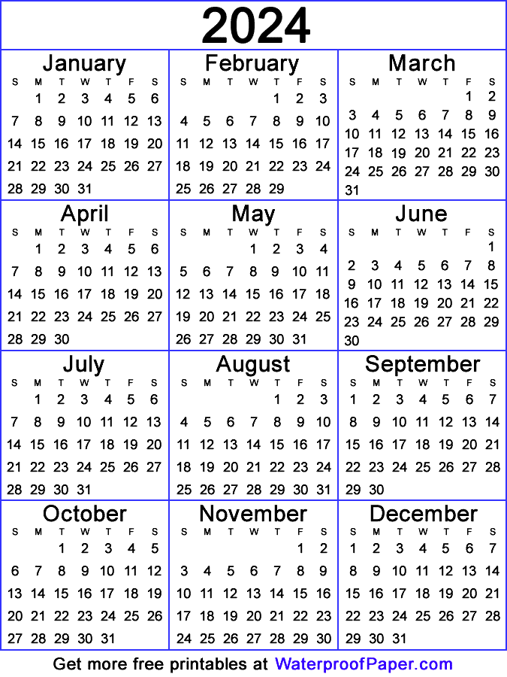 

**January**

Jan 2-31 Winter Clothing Drive

Jan 9 Thur Membership Meeting (Rosary 6:30/Meeting 7:00)

Jan 10-11 State Meeting (Fredericksburg)

Jan 22 Wed Exemplification at Holy Family 7:00pm

Jan 30 Thurs Officers Meeting (7:00pm)

**February**

Feb 2-3 Sun-Mon Special Olympics Polar Plunge

Feb 6 Thurs Membership Meeting (Rosary 6:30/Meeting 7:00)

Feb 22 Sat Parish Life Casino Night

Feb 27 Thurs Officers Meeting (7:00pm)

**March**

Mar 1 State Meeting (Richmond)

Mar 4 Shrove Tuesday Pancake Dinner

Mar 5 Ash Wednesday

Mar 6 Thurs Membership Meeting (Rosary 6:30/Meeting 7:00)

Mar 11 Tues Lenten Soup Supper

Mar 15 Sat St. Patrick’s Day Dinner

Mar 18 Tues Lenten Soup Supper

Mar 22 Sat State Free Throw Competition (Goochland)

Mar 25 Tues Lenten Soup Supper

Mar 27 Thurs Officers Meeting (7:00pm)

**April**

Apr 1 Tues Lenten Soup Supper

Apr 3 Thurs Membership Meeting (Rosary 6:30/Meeting 7:00)

Apr 8 Tues Lenten Soup Supper

Apr 15 Tues Lenten Soup Supper

Apr 20 Easter Sunday

Apr 24 Thurs Officers Meeting (7:00pm)

Apr 27 Sun Wives Appreciation Brunch

**May**

May 1Thurs Membership Meeting (Rosary 6:30/Meeting 7:00)

May 2-4 State Annual Meeting (Virginia Beach)

May 21 Wed Exemplification at Holy Family 7:00pm

May 29 Thurs Officers Meeting (7:00pm)

**June**

June 5 Thurs Membership Meeting (Rosary 6:30/Meeting 7:00)

June 26 Thurs Officers Meeting (7:00pm)

